Documentation for NYS Energy Code (ECCCNYS-2020) Permit Applications Residential 1 & 2 Family and MF < 3 Stories
Please provide the following documentation to demonstrate compliance with the NYS Energy Code for any project you submit for a building permit:
- Drawings shall include full Energy Code compliance details and specifications (preferably on a single sheet) including but not limited to:

- Attic, Walls, Foundation Insulation Specs | - Heating & Cooling Systems Specs
- Window U-Value & Infiltration Specs | - Service Water Heating Specs
- Air & Vapor Barrier Specs | - Mechanical Ventilation System Specs
- Duct Sealing & Insulation Specs | - Elec Power & Lighting System Specs
- Heating Piping Insulation Specs | - Programmable Thermostat Specs
- REScheck full reports as required by jurisdiction
- Statement on Drawing documenting that the Design meets the Energy Code per ECCCNYS Section R105.2.2
- Energy Code Compliance Path Documentation (One of the following is required):
  - Prescriptive Approach including All Compliance Documentation (R401 thru R404)
  - Total UA Alternative (R405 and R401 thru R405 “Mandatory”) - REScheck reports if those methods are used for Compliance
  - Simulated Performance Alternative (R405 - Statement from a HERS Rater outlining Compliance with Performance Approach including sufficient reports to demonstrate Mandatory Requirements have been met)
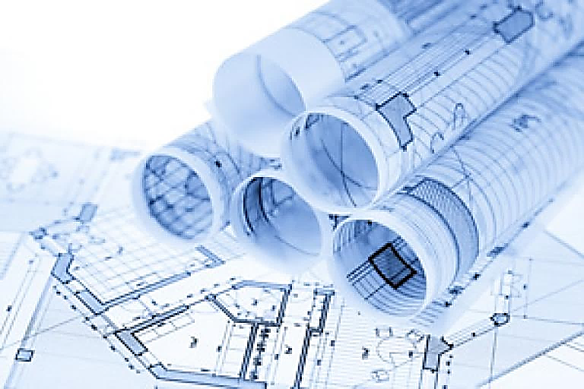
  - Energy Rating Index (R406 - Statement from a HERS Rater outlining Compliance with the ERI method including sufficient reports to demonstrate Mandatory Requirements have been met

Documentation for NYS Energy Code (ECCCNYS-2020) Permit Applications Commercial and Multifamily > 3 Stories
Please provide the following documentation to demonstrate compliance with the NYS Energy Code for any project you submit for a building permit:
- Drawings shall include full Energy Code compliance details and specifications (preferably on a single sheet) including but not limited to:

- Attic, Walls, Foundation Insulation Specs | - Heating & Cooling Systems Specs
- Window U-Value & Infiltration Specs | - Service Water Heating Specs
- Air & Vapor Barrier Specs/Details | - Mechanical Ventilation System Specs
- Duct Sealing & Insulation Specs | - Elec Power & Lighting System Specs
- Heating Piping Insulation Specs | - Programmable Thermostat Specs
- Commissioning Plan | - Mechanical System Design Criteria
- COMcheck full reports as required by jurisdiction
- Statement on Drawing documenting that the Design meets the Energy Code per ECCCNYS Section C105.2.2
- Energy Code Compliance Path Documentation (One of the following is required):
  - ASHRAE Compliance Path: The requirements of ASHRAE 90.1-2016 (as amended) including documentation demonstrating all Mandatory Requirements have been met. COMcheck for ASHRAE 2016 acceptable
  - Prescriptive Compliance Path: The requirements of Sections C402, C405 and C408 including documentation demonstrating all Mandatory Requirements have been met. In addition, commercial buildings shall comply with Section C406 and tenant spaces shall comply with Section C406.1.1.
  - Performance Compliance Path: The requirements of Sections C402.5, C403.2, C404, C405.2, C405.3, C405.5, C405.6, and C407 including documentation demonstrating all Mandatory Requirements have been met. The building energy cost shall be equal to or less than 85 percent of the standard reference design building.
  - COMcheck Computer Software: Compliance with the 2015 IECC Commercial Provisions (as amended) or, if applicable, with ASHRAE 90.1-2016 (as amended) can be demonstrated through the use of COMcheck computer software including documentation demonstrating all Mandatory Requirements have been met. Can be used for bullets 1&2 above)

